

ASSET VERIFICATION AND RECORDING TOOL KIT


Plot 31, Bukoto Street
P.O Box 7657, Kampala, Uganda
+256 (0) 39 2000216/0772525235
email: cpa@cpa.ug

www.cpa.com

August to September 2026

VERIFICATION DETAILS

NAME OF THE REGION: | CENTRAL
SUB-REGION: | BUGANDA
Name of Local Government | MUBENDE
VERIFIER PARTICULARS
Full name | JALIYAH BALUUBU
Contact/ email and Telephone | Jaliahb45@gmail.com  0794775877
Supervisor/ Sub team leader
Name | Prof: MBONIGABA DEPAUL
Contact | 0788483159
Date of submission | 06/09/2026

HEALTH CENTRES
INFORMANT INTERVIEW/DISCUSSION GUIDE (INCHARGE OR RESPONSIBLE PERSON)

Name of Health Centre:

1a | Does the Facility have a record of all assets provided under UgIFT.  (Obtain a record and verify if it has the costs and numbers supplied
1b | If Not ask how many were supplied and when.

2 | How does this facility Maintain (repair/service/replace) the assets provided under Ugift

3 | Does the facility take regular record about functionality/ or breakdown of the assets provided?

4 | How has the UgIFT support helped in service delivery in the area, any issues, challenges and any recommendations for better program implementation.

PROCEED TO VERIFICATION AFTER THIS DISCUSSION

Health centre checklist

NAME OF LG
NAME OF HEALTH FACILITY

Equipment/ Item | Department | Asset Number | Item  Description | Life in Months | Tag Number ( engrave no.) | Date Of Purchase | Date Placed In Service | Recoverable cost | Cost | Acc Dep Cost | Net Book Value | Ytd Deprn | Equipment status | Remarks

SCHOOL VERIFICATION CHECKLIST

SCHOOL INTERVIEW/DISCUSSION GUIDE

Name of school: KIGANDO SEED SECONDARY SECONDARY SCHOOL

1a | Does the Facility have a record of all assets provided under UgIFT.  (Obtain a record and verify if it has the costs and numbers supplied | yes
1b | If Not ask how many were supplied and when.

2 | How does this facility Maintain (repair/service/replace) the assets provided under Ugift

The school has a portion off the school budget to handle damage emergencies

3 | Does the facility take regular record about functionality/ or breakdown of the assets provided?  Nonfunctional/ working, and reasons for non-functionality. | Not applicable

NOT APPLICABLE as most of the assets have not been fully handed over to the school administration

4 | How has the UgIFT support helped in service delivery in the area, any issues, challenges and any recommendations for better program implementation.

UGIFT program has improved, promoted and eased the teaching of both the science and computer subjects.

The incharge said that most of the assets are not yet handed over to the school administration which has delayed the beginning of science and computer teachings.

The incharge recommended that the contractor should hurry and handover the assets fully so that students start studying science and computer subjects compresively

PROCEED TO VERIFICATION AFTER THIS DISCUSSION

SCHOOL FURNITURE
(School Desks, Office chairs, Laboratory stools, Book shelves)

Name of SCHOOL KIGANDO SEED SECONDARY SCHOOL

Equipment/ Item | Department | Asset Number | Item  Description | Life in Months | Tag Number ( engrave no.) | Date Of Pur | Date Placed In Service | Recoverable cost | Cost | Acc Dep Cost | Net Book Value | Ytd Deprn | Equipment status | Remarks
School desks | Education |  | Wooden varnished desks |  | Ugift/KIGANDO SEED S.S 004  Ugift/KIGANDO SEED S.S 002 | l |  |  |  |  |  |  | Functional | 120 desks well engraved and functional
Office chairs | Education |  | Wooden varnished |  | UGIFT/KIGANDO SEED S.S 004  UGIFT/KIGANDO SEED S.S OO6 |  |  |  |  |  |  |  | Functional | 180 chairs engraved and functional
Laboratory stools | Education |  | Varnished wooden |  |  |  |  |  |  |  |  |  | pending | 96 stools pending to be yet received by the school
Laboratory tables | Education |  | Well varnished wooden tables |  |  |  |  |  |  |  |  |  | Not functional | 24 tables still in pending
Laboratory gas taps | Education |  | Gas taps |  |  |  |  |  |  |  |  |  | Not functional | 42 pendint to be received by the school
Computer lab tables | Education |  | Well varnished wooden tables |  | Not engraved |  |  |  |  |  |  |  | Not Functional | 42 tables not yet handed over to the school
Computer lab hard chairs | education |  | Well varnished wooden chairs |  |  |  |  |  |  |  |  |  | Not functional | 90 chairs pending handover
Multi purpose hall tables | Education |  | Well varnished wooden tables |  |  |  |  |  |  |  |  |  | Not functional | 24 tables pending of handover

ICT ITEMS TO VERIFY
(Desktop Computer, Server Processor, Network Switch 24 Port, Multipurpose Printer, UPS, Projector, Air Conditioners, Server, CCTV Camera)

Name of LG MUBENDE

Name of SCHOOL KIGANDO SEED SECONDARY SCHOOL

Equipment/ Item | Department | Asset Number | Item  Description | Life in Months | Tag Number ( engrave no.) | Date Of Pur | Date Placed In Service | Recoverable cost | Cost | Acc Dep Cost | Net Book Value | Ytd Deprn | Equipment status | Remarks

BUILDINGS TO VERIFY
(Non- Residential and Residential, Kitchen, Toilets/Pit latrine Water tanks, Fences etc.)

Name of LG MUBENDE
Name of SCHOOL KIGANDO SEED SECONDARY SCHOOL

Equipment/ Item | Department | Asset Number | Item  Description | Life in Months | Tag Number ( engrave no.) | Date Of Pur | Date Placed In Service | Recoverable cost | Cost | Acc Dep Cost | Net Book Value | Ytd Deprn | Equipment status | Remarks
Laboratory water taps | education |  | Water taps |  | Not engraved |  |  |  |  |  |  |  | Not functional | 28 water taps pending of hand over to the school administration
Staff toilets | Education |  | Well built 1 block of 2 stances and a bathroom |  |  |  |  |  |  |  |  |  | functional | Fully functioning and in good shape
Staff quarters | Education |  | 3 blocks of two units of two rooms |  |  |  |  |  |  |  |  |  | Functioning | Construction still in progress
Student toilets | Education |  | 2 blocks of respective gender boys and girls of 5 stances with a dressing room on the girls’ block |  |  |  |  |  |  |  |  |  | Fully functioning | Good shape and already in use
Kitchen | Education |  | 2 blocks of 2 rooms |  |  |  |  |  |  |  |  |  | Functional | In use
Student Laboratory | Education |  | I block of 2 rooms |  |  |  |  |  |  |  |  |  | Functional l | In use
Computer lab | education |  | I block of 2 rooms with a library |  |  |  |  |  |  |  |  |  | Functional | In use
Multi purpose hall | Education |  | I block of 2 entrances |  |  |  |  |  |  |  |  |  | Functional | In use
Staff quarters toilets | Education |  | 2 blocks of two stances and a bathroom |  |  |  |  |  |  |  |  |  | Functional | In use
Staff quarters kitchen | Education |  | 3 blocks of 2 units |  |  |  |  |  |  |  |  |  | Functional | In use
classrooms | Education |  | 3 blocks of two classes |  |  |  |  |  |  |  |  |  | Functional | In use
Water tanks | education |  | 5000, 3000, and 10000 ltrs |  |  |  |  |  |  |  |  |  | Functional | In use
Sports field | Education |  |  |  |  |  |  |  |  |  |  |  | Functional | Still incomplete
Administration block | Education |  | I block |  |  |  |  |  |  |  |  |  | Functional | Functional
Fire extinguishers | Education |  | Fire extinguishers |  |  |  |  |  |  |  |  |  | Not yet functional | 8 but still pending handover

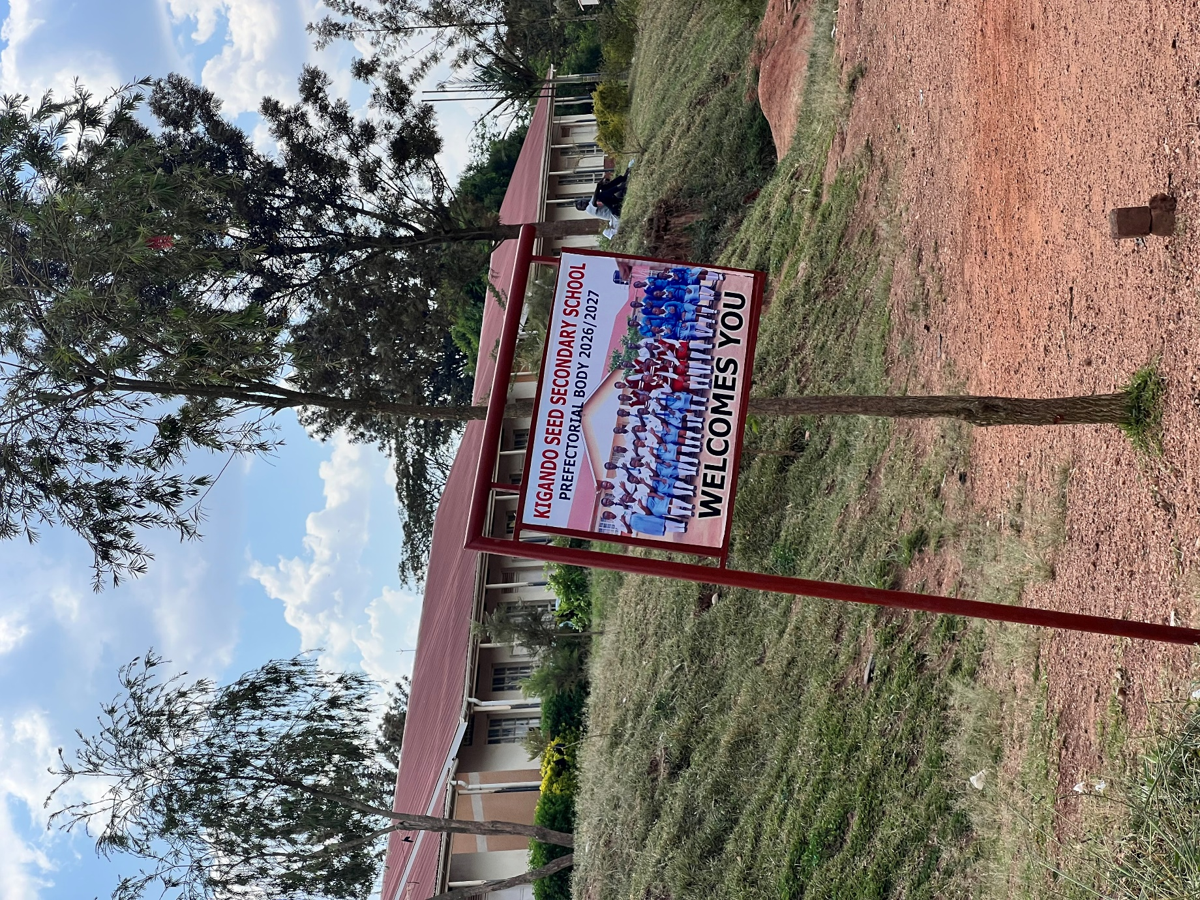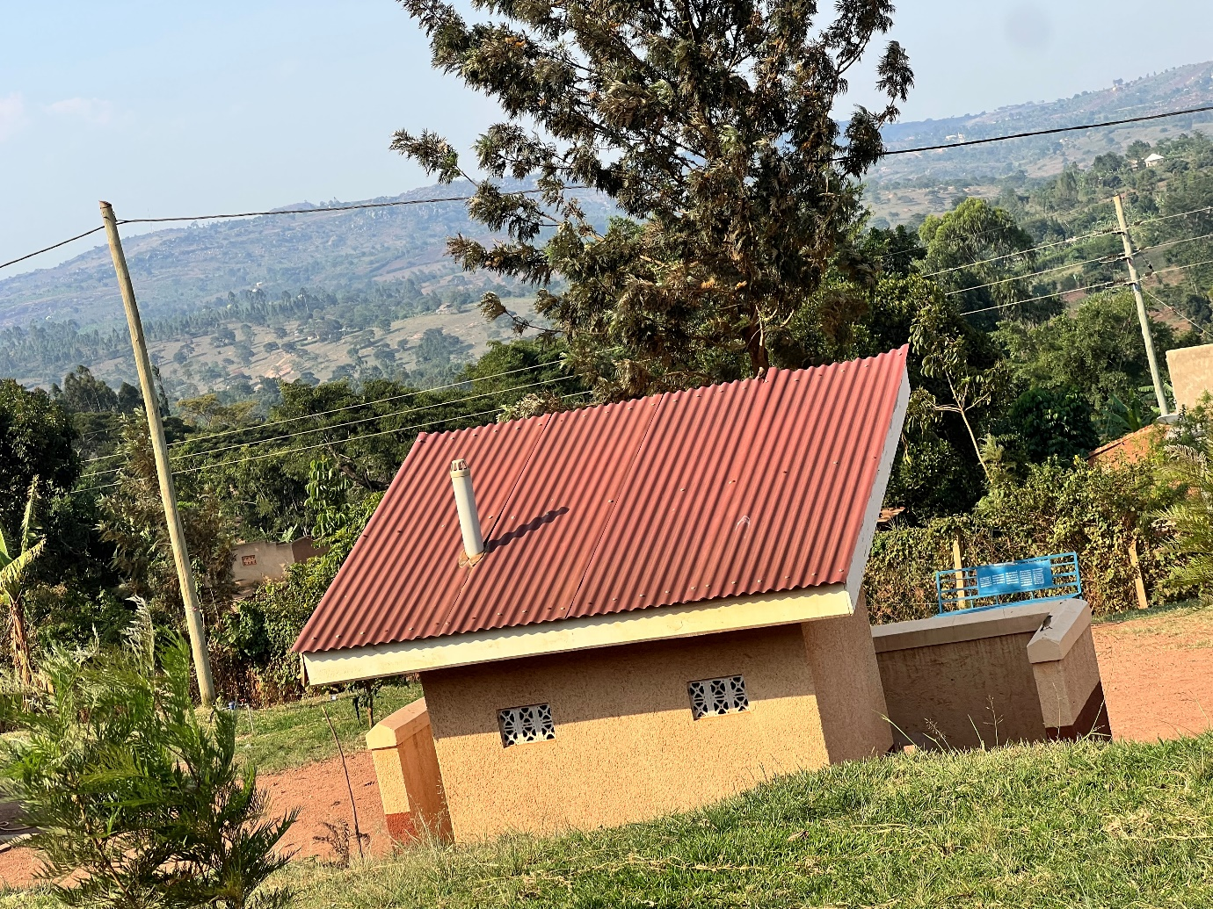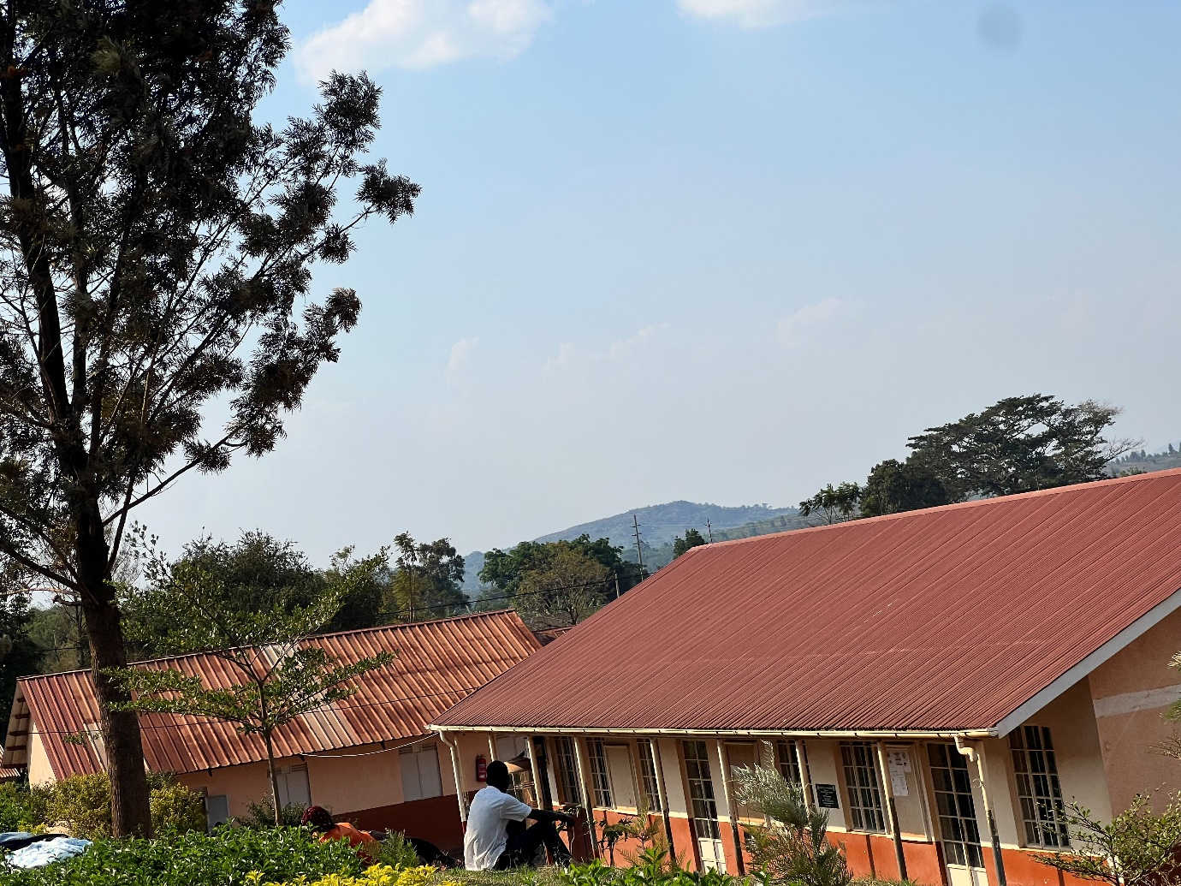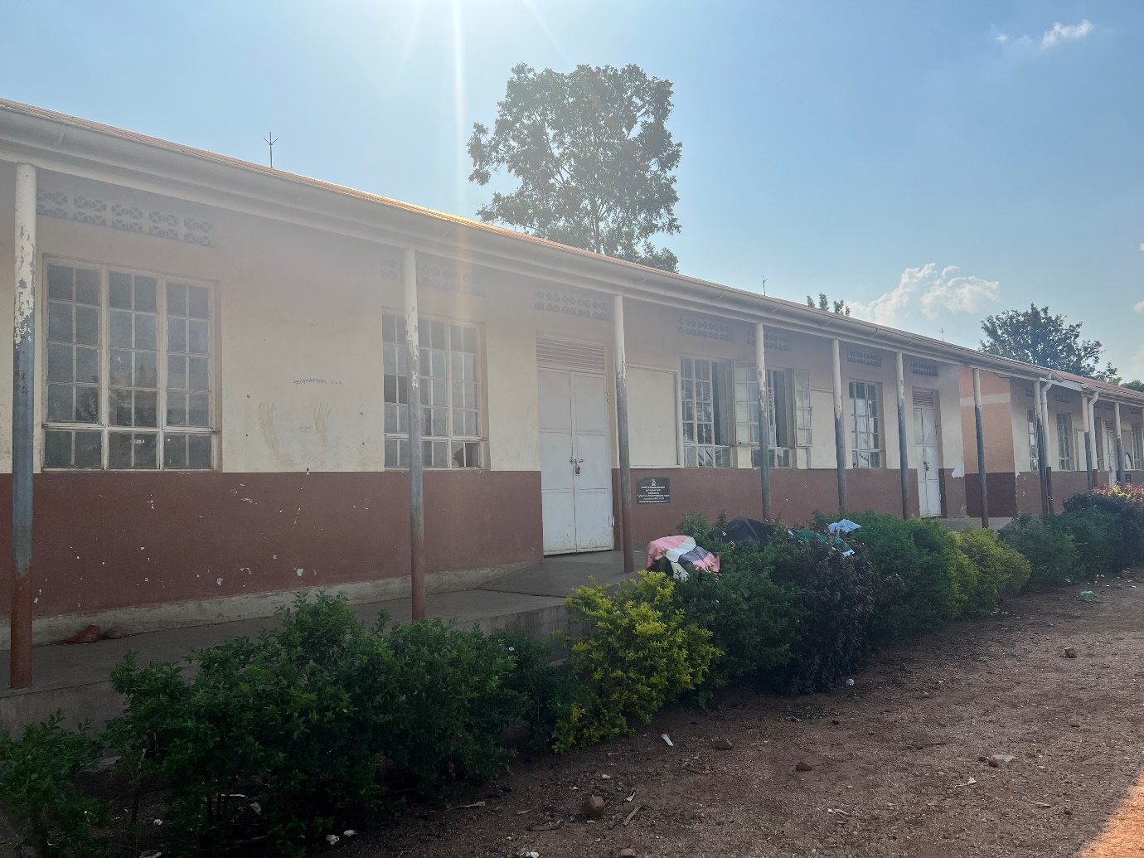
Staff latrines
Full functional classrooms

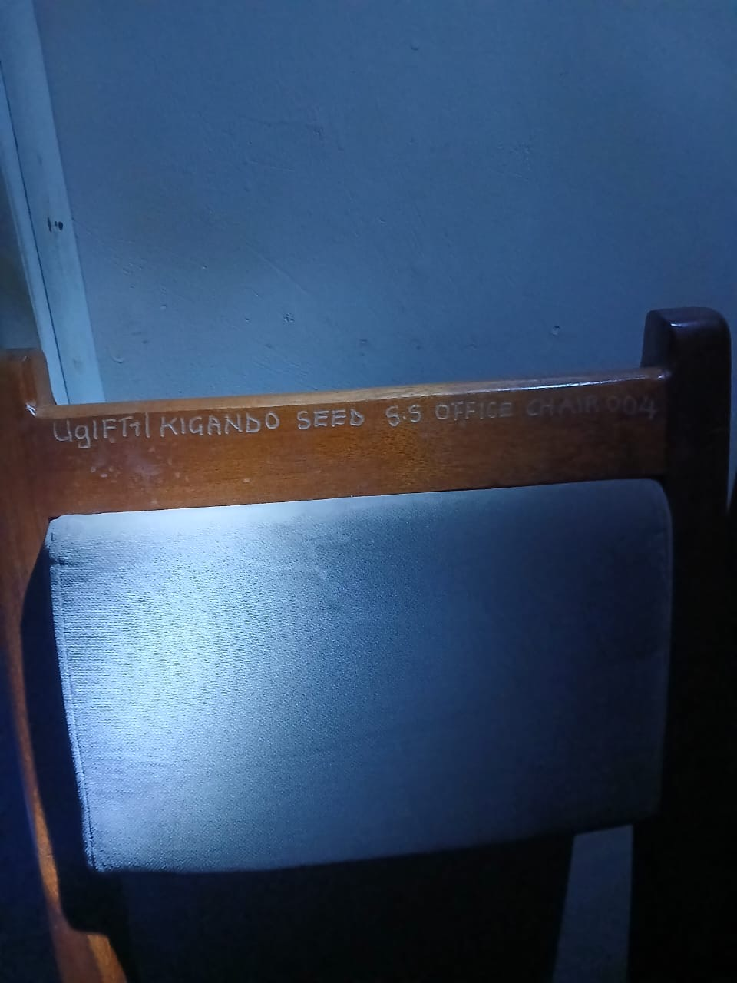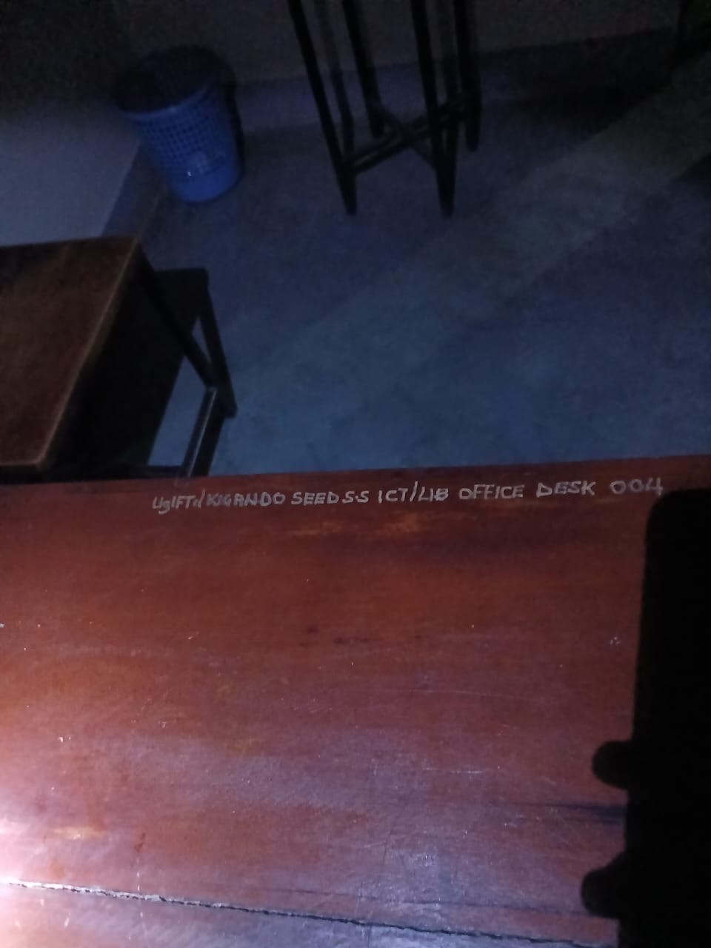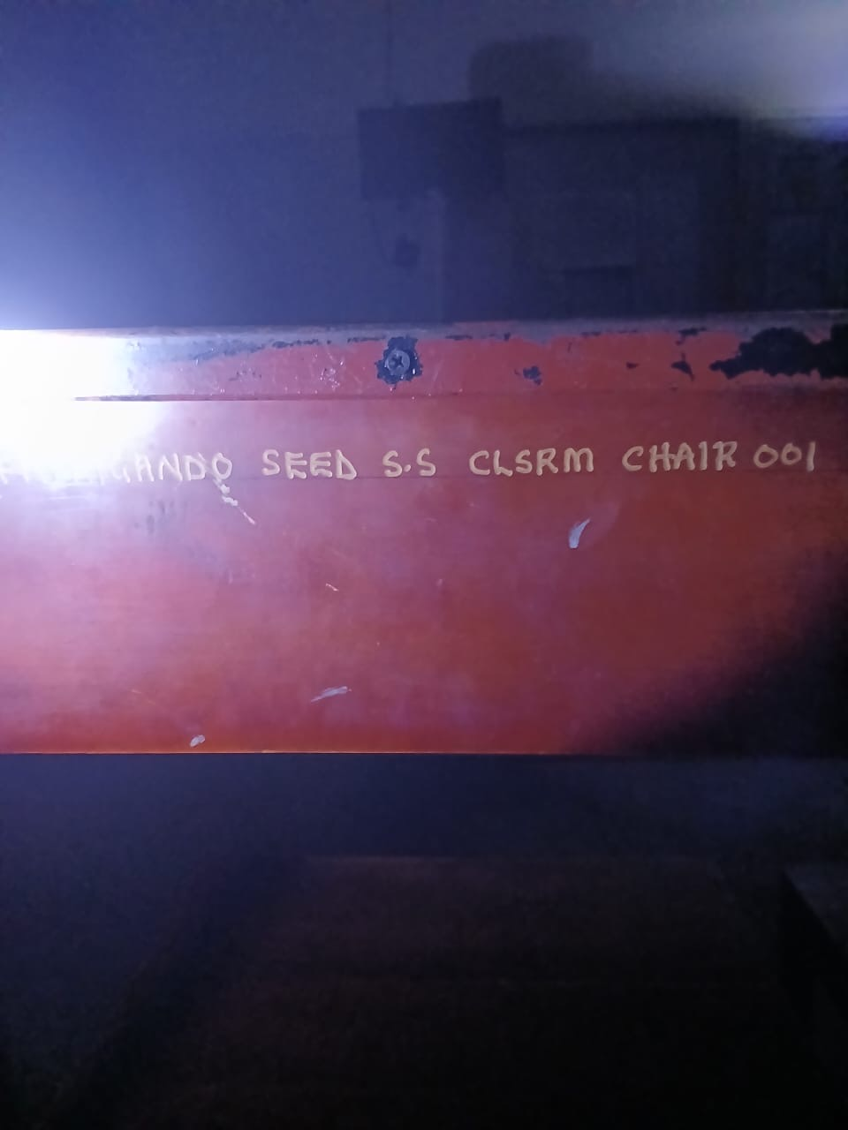
Engraved chairs
Engraved desks

